Individual Project Ideation

Balan Mihai-Stefan, class 29_S2_CB01

Git repository link: <https://git.fhict.nl/I501909/individual-project-sem-2.git>

**1.Brief overview**

The app I would like to develop for my semester 2 individual project is a Management System for Satellites and Space Stations around Earth. This system will be meant for engineers and scientists working directly with the devices, as well as for enthusiasts in the public who wish to contribute to the work. These two big categories will have separate environments within the solution.

The desktop application will be meant for the certified workers in the domain. Users have the options to add a space object (satellite, space station, other kinds of space debris) and introduce all their parameters (position, altitude, speed, etc.). In case something is wrong, they can remove the object or update the object’s data.

This part is very expandable, as many features can be added to a system like this. An example would be collision prevention, or launch management.

The web application will be meant for the public users. While not logged in, they can see limited info about space objects in orbit. They can observe issues and report them to the workers.

A built-in mailing system would allow users that are logged in to send their reports to the labs, from which professionals can take over, or reply to the user for clarification. In case the user notices he has made an error, he can delete or edit the message. A worker can delete messages as well, while also having the option to ban users from the platform for things such as profanity, hate speech, etc.

This part can also be expanded with quality of life changes, UX updates and more possible user interaction with features that would be added to the worker’s side.

**2.Sitemap – Web Page Description**

The site will have four core pages, at first:

* The Main Page / Landing Page: contains the company’s name, the slogan, some details about their work, the contact details in the footer, and a navigation bar in the header. All of the following pages can be accessed from the navigation bar on the main page.
* Login/Register page: user can choose whether to register or sign in. On registering, a bit more details than the average account will be required, because of the nature of the service. Of course, the login page will require the email and password.
* Map page: Will be very similar to the map featured by the mobile app

‘ Flightradar24’. Building a 3D map like Google Earth, that also features space object precisely placed is above my skill level. The map would be a 2D representation of Earth, seen from above, like the maps used in geography classes. Objects that are orbiting earth will also have the orbit traced, but barely visible. Individual objects can be selected and highlighted.

* Mailing page: will require users to enter the ID/Name of the object they want to talk about, and will allow users to see multiple conversations, sorted by object. Also, replies are received for a specific object too. This page can be accessed from the map page, in which case the selected object’s name will be automatically filled. Users can ‘unsend’ an individual message, or delete an entire conversation, but just for themselves.

**Content of app:**

* Website about space objects
* Desktop App to manage all objects
* Variation: Satellites, Stations, Debris – inherit from SpaceObject
* Additional entities: TelemetryData, Launch, DataVisualization, OrbitData, etc.

All of the previously mentioned features will be expanded in future versions. Also, new web pages may be added.

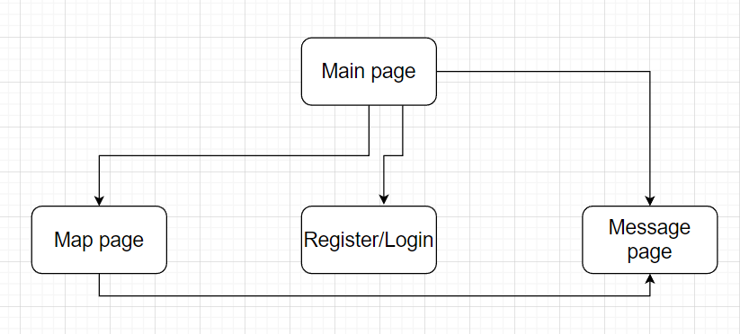

*See in the picture above a simple sitemap for the early versions of the web app side.

**3.Wireframe of Web Pages – The first prototypes**

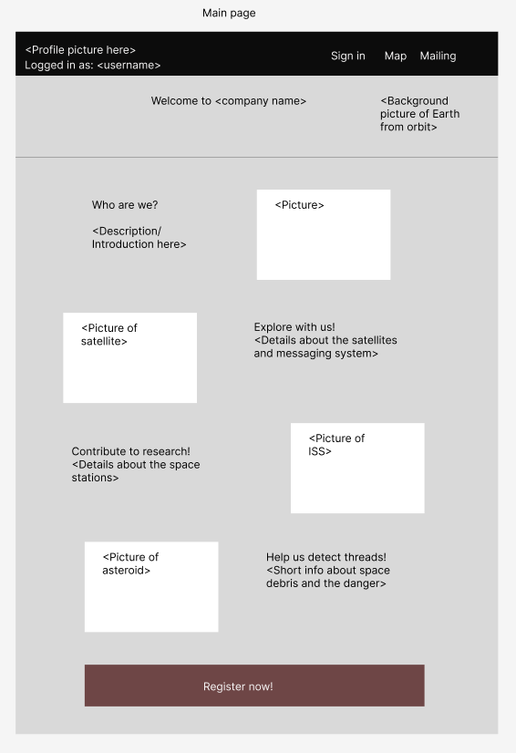

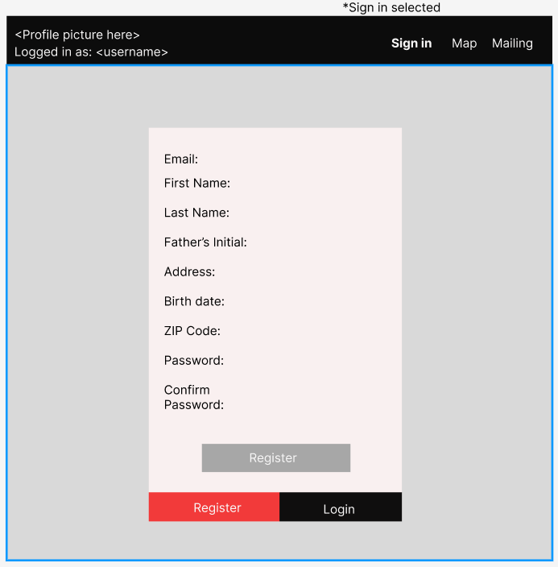

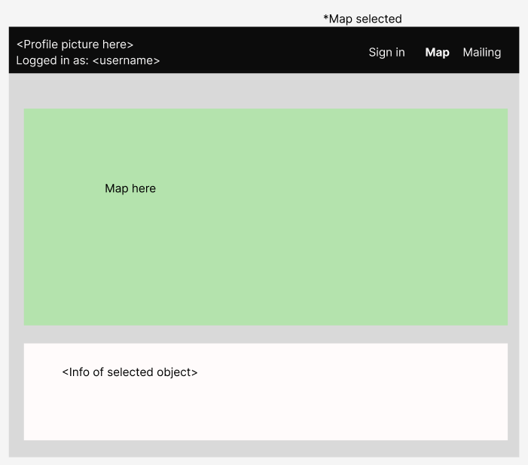

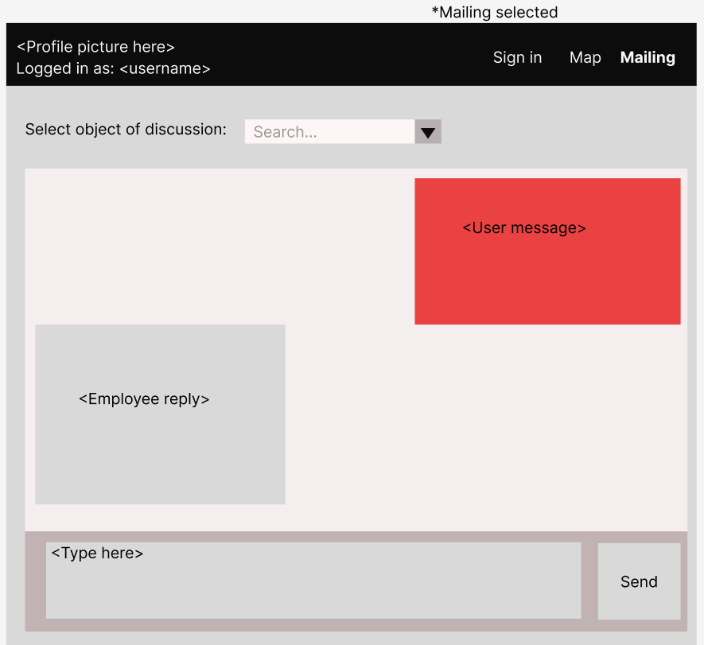

The presented prototypes are very general and not detailed. They are meant to present my vision of how the web side of the app would look like. Many features can be added after the start of development.

**4.Conclusion**

This has been my initial impression on how to implement my idea for the individual project. When deciding, I kept in mind expandability over 18 weeks, satisfying all the learning outcomes and also integrating my passions into my work. I am expecting this document to receive corrections and to consider the feedback and modifications my teachers will provide before starting the implementation phase.